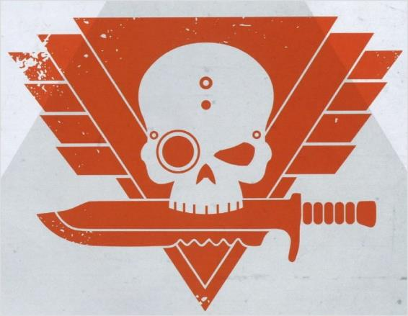

Kill Team Narrative Campaign: Promethium Wars

Campaign Overview

The war for Pyrothis V rages in the shadows. This barren, scorched world is a vital promethium hub, its refineries and pumping stations feeding the war machine of the Imperium. But Chaos forces have infiltrated the planet, seeking to seize control of its volatile resources and turn the tide of the sector-wide war.

With conventional warfare too dangerous—one stray macro-cannon round could ignite a global firestorm—both sides have turned to elite kill teams to strike at key infrastructure. Sabotage, assassinations, and surgical strikes will determine which faction gains control over Pyrothis V’s lifeblood.

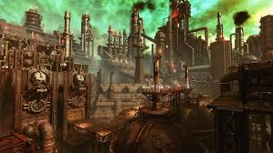

Promethium refinery on Pyrothis V

Basic Rules

**Duration:** The campaign lasts 4 weeks. Starting on Weds 23rd April finishing on 20th May.

**Games:** Participants can play games at any time during the 4 week period, at 40K in Freo, at home, in the pub, at the kitchen table, wherever. Your opponent does not have to be participating in the campaign, although it’s more fun if they are. But please be honest about the result.

While this is predominantly a Kill Team campaign, games of joint ops, 40K and combat patrol will also count.

**Victory Points:** Each game won earns 1 point for your faction (Imperium or Chaos). At the end of the 4-week campaign, the faction with the most points wins. However, the Xenos faction wins if it can force a stalemate between the Imperium and Chaos (if their VP totals are within 2 of each other).

**Kill Teams:** Players can play 1 or more Kill Teams for the duration of the campaign, each adding points to their aligned faction.

**Xenos Teams:** Xenos teams are not aligned with either faction. Instead acting as pirates, mercenaries and raiders with their own agenda. At the start of each battle, Xenos players choose which faction to fight for and their points are allocated accordingly.

**Narrative Focus:** This is a story-driven campaign, so showcase your kill teams, battle reports, and cinematic moments in the Discord! Bragging and lamenting are encouraged.

**Reporting Results:** Send all battle results to the Campaign Master (Dashing Blade-Tom) and post about your victory or defeat on Discord.

At the end of four weeks, the faction with the most Victory Points secures Pyrothis V, turning the tide of war in the sector!

Will the Imperium secure its vital supply lines, or will Chaos plunge the sector into ruin?

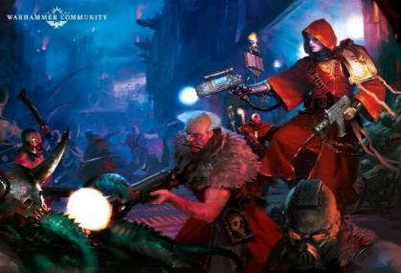

Narrative Engagement

The key to this campaign is to tell the story of Pyrothis V and the brave (foolhardy) teams fighting over her resources.

**Tell Your Story:** Post your battle reports, game pics, cinematic moments, and war-torn narratives in the Discord.

**Faction Propaganda:** Trash talk your rivals, forge grudges, and rally your side.

**Character Growth:** Track the deeds of your operatives—who’s a hero, and who’s a liability?

**Scenarios:** Feel free to add environmental conditions and custom scenarios that fit the weeks theme to your game and share with the group.

Engaging with this side of the game will make the campaign really sing.

Schedule

**Now –** Introduce your Kill Team on the Discord Channel, give a little back story and why they are involved with the conflict on Pyrothis V.

**Week 1: Weds 23 April – Infiltration and Sabotage.**

* **Battlefield Conditions:** Many engagements take place at night or in tight industrial spaces. Missions may favour stealth, hacking objectives, or placing explosives.
* **Narrative Hooks:**
  + A kill team sneaks into a refinery to poison its fuel stores.
  + A covert strike eliminates an enemy officer before reinforcements arrive.
  + A communications relay must be destroyed before critical orders are transmitted

**Week 2: Weds 30 April – Open Conflict**

* **Battlefield Conditions:** Urban and industrial warfare, with refineries, drilling stations, and fuel depots serving as contested battlegrounds.
* **Narrative Hooks:**
  + A kill team must hold a refinery until reinforcements arrive—or die trying.
  + Chaos warbands stage a brutal assault on an Imperial stronghold.
  + A Xenos faction decides who they will back in the coming war.

**Week 3: Weds 7 May - Firestorms & Disaster (Get some extra games in at the Tabletop Freo Expo!!)**

* **Battlefield Conditions:** Unstable terrain, hazardous environments, and unpredictable dangers. Promethium fires, toxic spills, and crumbling structures change the battlefield mid-game.
* **Narrative Hooks:**
  + A raging inferno threatens to engulf both forces—can they complete their mission before being consumed?
  + A desperate escape through collapsing tunnels.
  + A kill team’s last stand as enemy reinforcements arrive amid the chaos.

**Week 4: Weds 14 May: Final Gambit – Double points this week!**

* **Battlefield Conditions:** Final battles in crucial locations—the last remaining refinery, an abandoned control tower, or a collapsing fortress.
* **Narrative Hooks:**
  + A brutal last-ditch counteroffensive to reclaim lost ground.
  + A desperate mission to sabotage enemy fuel supplies before they can be used.
  + A warlord's personal kill team leads the charge, determined to claim victory or die trying.